Comparison of noise data (March, April 07) with PATCH file by B. Doenigus

Procedure:

Generation of noise data file:
The noise data file was generated by a macro used for reading from a digit file, analyzing and plotting data. The macro has been modified to give out ADC mean and RMS values of all pixels in SM08 with chamber, row and column information.

//loop through the detector pixel for all timebin

for (Int_t col = 0; col < colMax; col++) {
for (Int_t row = 0; row < rowMax; row++) {
for (Int_t time = 0; time < nTimeTotal; time++) {
digit = digitsManager->GetDigit(row,col,time,iDet);

//get rob and mcm id
robid=geo->GetROBfromPad(row,col);
mcmid=geo->GetMCMfromPad(row,col);
//exclude “0-digits”
if (digit->GetAmp()>0)
{
// get ADC for one pixel
hDigit1D1pixel->Fill(digit->GetAmp());
}
delete digit;
}
// get histogram pixelno. vs. ADC
pixelpedmean->Fill((iDet-detBeg)*144*16+colMax*row+col,hDigit1D1pixel->GetMean());
// get histogram pixelno. vs. RMS
pixelpedrms->Fill((iDet-detBeg)*144*16+colMax*row+col,hDigit1D1pixel->GetRMS());
hDigit1D1pixel->Reset();
}
}

……………………….

//output of all pixel information (chamber, row, column, ADC Mean, RMS)
for(int i=0;i<69120;i++)
{
cout<<"Pixel #: "<<i<<" Chamber#: "<<i/2304<<" row#: "<<(i%2304)/144<<" column#: "<<(i%2304)%144<<" adc: "<<pixelpedmean->GetBinContent(i+1)<<" RMS: "<<pixelpedrms->GetBinContent(i+1)<<endl;
}

In order to compare this data file with the PATCH file, I had to make sure they have the same format, i.e. chamber, ROB, MCM, iadc number. The data file was modified using built-in methods:
robid=geo->GetROBfromPad(row,col);
mcmid=geo->GetMCMfromPad(row,col);
adc=17-(col%18)+2;
The PATCH file was generated by online software. The threshold for noisy pixels was RMS>2.5. Its format had to be changed too. Here is an example of this format:
L3C1-021
// highnoise: irob=1, imcm= 7 iadc=2 rms=8.30
ERR:ADC F0_T1B_V1_N0112 7, 0x1ffff8;
L3C1-021 stands for chamber 249 (see also http://www.physi.uni-heidelberg.de/~demscher/alice/links). Also I only used the lines starting with “//highnoise”, which contain the ADC and RMS information (ADC patch). At the end the format was something like this:
chamber= 249 irob= 1 imcm= 7 iadc= 2 rms= 8.30
Now a macro was used to iterate the PATCH file, comparing each pixel in it with the pixel in the data file to check if it is patched (RMS=0).

Result:

Total number of pixels in PATCH file: 198
Total number of not-patched pixels: 44

To double-check this result I filtered the data for all pixels with RMS=0 and check if they appear in the PATCH file. Result: 213 pixels with RMS=0, thereof 59 not in the file.
The reason why so many pixels seemed to be unpatched is:
There are 21 pixels/channels per MCM (Internal TRAP numbering 0<=iadc<=20); 3 channels out of 21 belong to 2 MCMs:
  - 17 -> MCM 0, adc 2 & MCM 1, adc 20
  - 18 -> MCM 0, adc 1 & MCM 1, adc 19
  - 19 -> MCM 0, adc 0 & MCM 1, adc 18
Figure 1 shows the conversion between the mechanical numbering and the MCM channel numbering.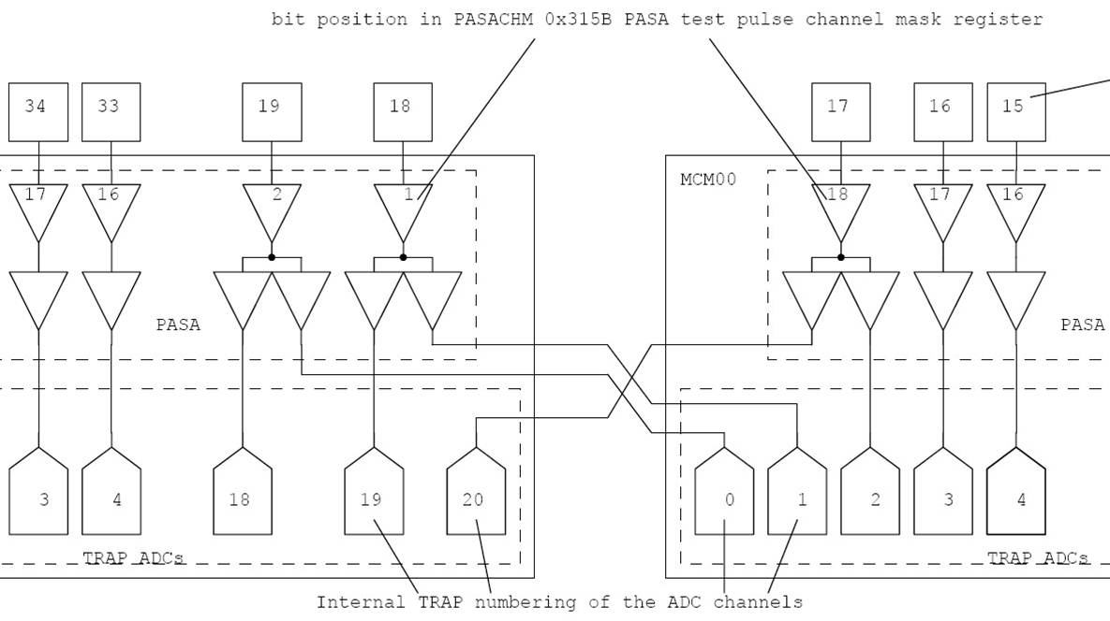
Figure 1: Numbering scheme of pixels and electronics

With current offline software only one signal is used: 2<=iadc<=19.
When a patch is applied, one of the 2 signals from this pixel is patched (RMS=0), but the other one still gives signal and can cause this patching problem.

The outcome of a comparison of data of last year (20060811) with another “PATCH file” by new data (same macro, same threshold, “online comparison”) was that the number of problematic pixels was reduced to 7 (191 OK). There is no common pattern so it’s hard to tell why these pixels remain unpatched. The RMS is above threshold, but not too high.
Pixel in Patch File and NOT patched: 249 ROB#: 1 MCM#: 15 adcid: 19 RMS : 2.63
Pixel in Patch File and NOT patched: 250 ROB#: 4 MCM#: 0 adcid: 19 RMS : 12.3
Pixel in Patch File and NOT patched: 250 ROB#: 6 MCM#: 13 adcid: 0 RMS : 6.9
Pixel in Patch File and NOT patched: 267 ROB#: 0 MCM#: 10 adcid: 5 RMS : 5.52
Pixel in Patch File and NOT patched: 268 ROB#: 1 MCM#: 11 adcid: 2 RMS : 7.05
Pixel in Patch File and NOT patched: 268 ROB#: 1 MCM#: 15 adcid: 2 RMS : 7.3
Pixel in Patch File and NOT patched: 268 ROB#: 5 MCM#: 11 adcid: 2 RMS : 7.83

The corresponding plots show that the other pixels are patched correctly.
For more plots please visit:
http://www.physi.uni-heidelberg.de/~seibel/Noise_SM08/
Figure 2: Chamber 254 – before PATCH
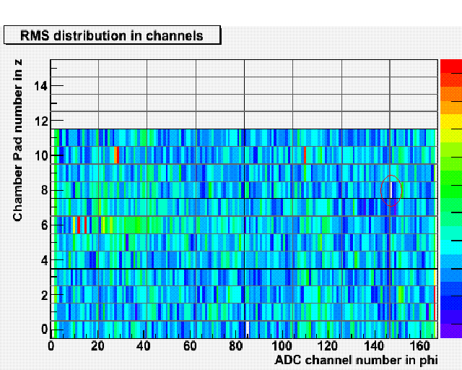
Figure 3: Chamber 254 – the pixel marked by the red circle shows no noise (white color), in Figure 2 it was noisy (RMS>2.5)
Figure 4: Chamber 255 – left edge is noisy

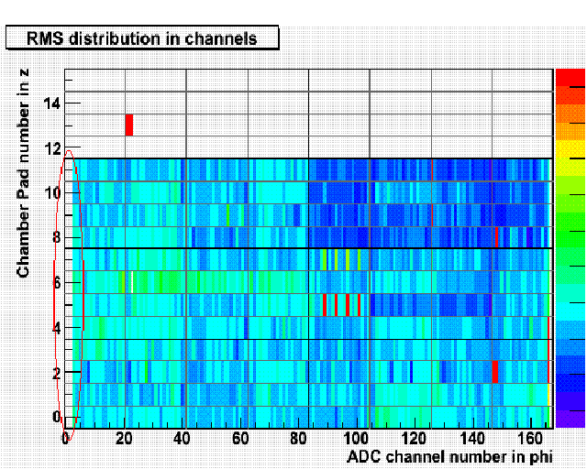
Figure 5: Chamber 255 – edge pixels are blanked out

